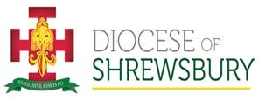
Diocese of Shrewsbury Training 2022

The Diocese will be running a series of training courses at venues across the Diocese in 2022

This training day will consist of two briefing sessions on:
Safeguarding and Health and Safety

The timetable for each day is:
09.15 – 9.45: Welcome refreshments
09.45 –11.00: Safeguarding
11.00 –12.00: Health and Safety (part 1)
12.00 –12.20: Refreshments
12.20 – 2.00 : Health and Safety (part 2)

The course descriptions are below followed by a booking form

We look forward to seeing you!

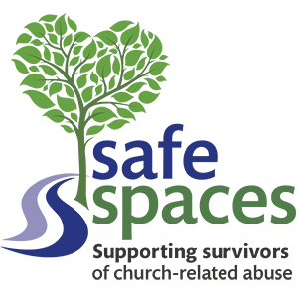

Creating a Culture of
Safeguarding

Safeguarding is as an integral part of the life and ministry of the Catholic Church.
Our parishes and communities can enable us to provide safe places of welcome where we can support and protect one another.

Since the coronavirus pandemic began a lot has changed around us, this disruption has presented a variety of challenges for people in our communities. The support made available within our parishes has culminated in a positive impact for many and we must continue to build upon this dedicated effort. Creating a safer culture in our churches is vital and requires everyone’s efforts for it to be achieved and sustained. Through simple everyday actions we answer our call from God to protect and care for those around us who may be vulnerable due to age, illness, disability or current and past experiences in their lives and respond compassionately to help keep them safe from harm. This important safeguarding ministry can be further supported within your parish and by the Safeguarding Office.

This session will raise safeguarding awareness in:

- Understanding your role & responsibilities in safeguarding.
- Protecting the vulnerable & protecting yourself.
- Knowing where to go for support and advice.
- Helping develop a culture of safeguarding.
- Accessing free training.
Andrew O’Brien, Diocese Safeguarding Coordinator will deliver the session and he has over a decade of professional safeguarding experience across local authority, education, and the faith sector.

Who is the session for? Everyone from across diocesan parishes.

Safeguarding is everyone’s responsibility!

Parish Health and Safety Awareness Session 

The Diocese Health and Safety Policy states that the responsibility for health and safety, within each parish, rests with the parish priests. The majority of the parishes across the Diocese have nominated Health and Safety Representatives to assist the parish priests with implementation of our health and safety policy.

This health and safety session is designed to make parishes aware of the health and safety duties that are necessary to have in place, to meet our legal requirements and to monitor them at regular intervals.

The awareness session will include the following areas:
- General health and safety and inspections
- Fire Safety awareness
- Working at height
- Risk assessment, including worked examples
- Lone working
- Manual Handling
- Accident reporting.

This session will be delivered by Julie Tinsley, Diocese Health and Safety Officer, and is aimed at Parish Priests, Parish Health and Safety Representatives and Parish Secretaries, who often assist in these matters.

How to book follows below…..

To book a place, please tick the box for the course(s) you wish to attend and email to Julie.Tinsley@dioceseofshrewsbury.org

Please title your email “Training Booking”

The courses are free. No lunch will be provided but there will be light refreshments available during the sessions

Name: ___________________________________

Parish / Organisation: ___________________________________

Role in Parish / Organisation (e.g. Health and Safety Rep, Safeguarding officer, Priest, Admin) __________________________________

Do you have any additional needs? __________________________________________

Venue | Date | Safeguarding  (9.45–11.00) | Health & Safety  (11.00-14.00)  Including a break from 12.00 -12.20)
St Anthony’s Parish Centre  Dunkery Rd, Wythenshawe, Manchester M22 0WR  (Places Very Limited) | 9 Nov 2022
St. Anne’s Parish Centre,  Highfield Road, Rock Ferry, CH 42 3BY  (Places available) | 1 Dec 2022

