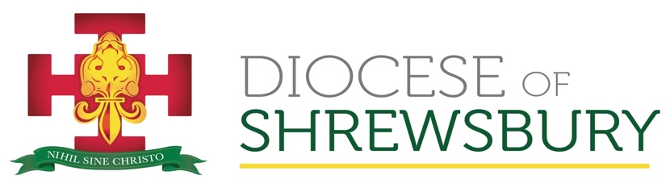
Department of Mission and Evangelisation

Adult Formation 2023

An Introduction to the Second Vatican Council (1962-65)
Part III: Section 1

Lumen Gentium
THE DOGMATIC CONSTITUTION ON THE CHURCH
Promulgated by Pope Paul VI on 21 November, 1964

- Some background:
- One of the Council’s four major Constitutions, this is designated ‘dogmatic’ because it makes a certain number of solemn declarations pertaining to what constitutes the Church’s nature, structure and mission.
- Work on it began in the second session of the Council, and the document had a long gestation. Roman dicasteries had prepared a text describing the Church in the customary neo-scholastic categories; this was rejected by the Fathers who felt that a different approach was needed.
- By autumn 1963, the proposed text had 5 chapters: The Mystery of the Church; The Church as the People of God; The Hierarchical Structure of the Church; The Laity; The Holiness of the Church. Three other chapters were added later.
- One of its aims was to continue and complete the reflections on the Church begun in the First Vatican Council (1869-1870). The Franco-Prussian War had interrupted proceedings, obliging the Bishops to return home; some therefore pushed for and obtained a definition of papal infallibility by bringing forward an item which had been number 11 of the 14 the Fathers had intended to address. The resulting definition was far more restricted than many hoped. The challenge now was to define the grace and role of all the Bishops in union with the Successor of Peter, the Bishop of Rome.
- With a view to ecumenism, the Fathers took a strongly biblical approach to defining the Church’s self-understanding, deeply rooted in salvation history and in God’s on-going search for each and every person culminating in the Son’s incarnation as Jesus of Nazareth.
- The first and essential affirmation is of the mystery of the Church: she arises in the heart and plan of the Father; is the reason for the sending of the Son; and the Holy Spirit’s mission is to bring her to completion.
- The Fathers stress the journey of the Church through time and space until her fulfilment in Heaven. Thus, she must both look back to the Jesus of history and forward in the Spirit of the Risen Lord to the coming of the Kingdom.
- As the ‘sacrament of salvation’, she is the (visible) sign of the (invisible) grace of God’s transforming action in her – and through her in the world.
- A leitmotif to note in the text: “As in Christ, so in the Church...”. E.g. the two-fold nature of Christ continues mysteriously in the two-fold nature of the Church, such that in her divine union with the Lord she is sinless; in her human members, she is wounded by sin. Holy in her being, she is called to holiness in conversion of belonging and behaving.
- In Christ, the Church is ‘missionary by nature’: i.e. she exists in order to proclaim the Gospel (to ‘evangel-ise’), which is to call all human beings to holiness and to provide the necessary means for everyone to come to this.
- In union with her members in Heaven, in her members on earth she is on pilgrimage towards her Heavenly Home with the Father in the Son through the Spirit.
- All are called to this. But there is one who is already, by grace, the embodiment of all that the Church, by grace, is in the process of becoming: Mary, Mother of Christ and of the Church.
- After much debate and many revisions, the document was approved by 2,151 to 5 Council Fathers.

- The Issues:
    - The inner nature of the Church, and her mission to and presence in the world
    - Are there two churches – one invisible/spiritual (as stressed by the Reformers) and one visible/institutional (as counter-stressed by theologians since then)?
    - Is membership of the Church necessary?
    - The relationship of the Catholic Church with other Christian communities
    - The relationship with the rest of humanity
    - The priestly, prophetic and kingly mission of the whole People of God
    - The hierarchical nature of the Church
    - The relationship between pope and bishops
    - The identity, grace and mission of the laity
    - The universal call to holiness, and a particular form of it in religious life
    - The relationship between Mary and the Church.

- The Document:
Chapter 1. The Mystery of the Church
Chapter 2. The People of God
Chapter 3. The Hierarchical Constitution of the Church (the Episcopate)
Chapter 4. The Laity
Chapter 5. The Universal Call to Holiness in the Church
Chapter 6. Religious
Chapter 7. The Pilgrim Church and her connection with Heaven
Chapter 8. The Blessed Virgin Mary, Mother of God in the Mystery of Christ and the Church.

- The Affirmations of Lumen Gentium
The document may be seen to explore 4 questions, to which it affirms 8 answers in its 8 chapters:
- Who is the Church? – Chapters 1 and 2
- How is the Church? – Chapters 3 and 4
- Why is the Church? – Chapters 5 and 6
- Where is the Church? – Chapters 7 and 8

* * *

