(NEWSLETTER INSERT)

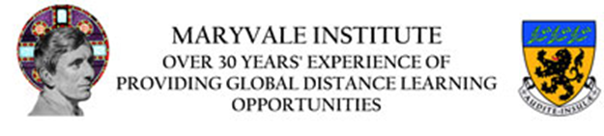

Maryvale Institute, Birmingham- Study part-time, by distance learning for a Bachelor of Divinity (BDiv) or a Licence in Divinity
The Maryvale Higher Institute of Religious Sciences (HIRS) is the only ecclesial institute of this kind in the English-speaking world.
The Ecclesiastical BDiv is a five-year part-time, collaborative-learning degree programme in Catholic theology providing a comprehensive exposition and analysis of Christian doctrine based on the study of the sacred Scriptures, the works of the Fathers and Doctors of the Church, and the documents of the Magisterium.
The Licence in Divinity: Pathway in Catechetical Sciences is another qualification of the Holy See, distinct from an STL, it is a three-year, part-time, programme aimed at those in leadership positions in catechetics and in other positions of responsibility.
Contact: Admissions tutor, Deacon Dr Harry Schnitker at: researchcentre@maryvale.ac.uk

