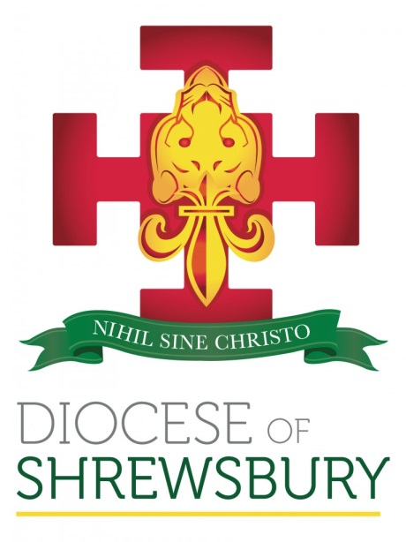

RCIA 2024

INFORMATION PACK
FOR CATECHISTS



CONTENTS

Invitation to the Reflection with Bishop Mark
Invitation to the Rite of Election
Booking Form
Directions to the Cathedral
Faculty Application Form
Faculty Guidance Notes

CONTACTS
Coordinator: Canon Christopher Matthews
Booking: Anthony Timothy

Curial Offices, 2 Park Road South, Prenton, Wirral, CH43 4UX
T: 0151 652 9855 E: anthony.timothy@dioceseofshrewsbury.org

www.dioceseofshrewsbury.org
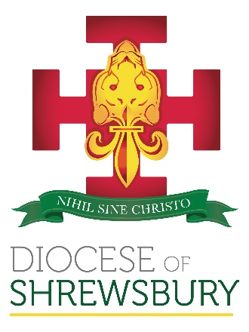 | Diocesan RCIA Coordinator  Canon Christopher Matthews  Curial Offices  2 Park Road South  Prenton  Wirral  CH43 4UX  Tel: 0151 652 9855  Mobile: 07813 020730  Email: anthony.timothy@dioceseofshrewsbury.org

RCIA Retreat Day and Rite of Election 2024

Dear Father, Deacon and RCIA Coordinator,

I write now with more details about the RCIA Refection time and Rite of Election in 2024. Please remember that these Diocesan events are not optional, but should form an integral part of the RCIA journey, so please encourage members of your RCIA group to join us at these events.

The Reflection with Bishop Mark takes place on Saturday 3 February 2024 and is for anyone considering receiving the Sacraments of Initiation this Easter. It is a time of quiet prayer and reflection for both Candidates (Baptised) and Catechumen (non Baptised). Sponsors, Godparents, and Catechists are also very welcome and are encouraged to attend. Please ensure you book places as soon as possible.

The day begins with coffee at 10:00am (please do not arrive too early!) and will include two reflections led by Bishop Mark, and will conclude with the Angelus prayer at Noon. Hot drinks and refreshments will be available on arrival. I am very grateful to the community of Holy Angels parish in Hale Barns for hosting the day in the Parish Hall, adjacent to the Church (Wicker Lane, Hale Barns, Altrincham WA15 0HF). Parking is available on-site.

The Rite of Election and Call to Continuing Conversion will take place on Sunday 18 February 2024, the First Sunday of Lent, at The Cathedral in Shrewsbury at 3pm. It is essential that parishes book places for both the Reflection with Bishop Mark and the Rite of Election.

This Parish Pack (attached) will also be uploaded to the Diocesan website as soon as possible. The pack includes:

An invitation to the Reflection with Bishop Mark that can be printed out and given to participants.

An invitation to the Rite of Election and directions to The Cathedral.
- Faculty Application Form and Guidance Notes. Please note: appropriate Faculties are required by parish priests when receiving adults and children of a catechetical age into full communion with the Catholic Church.

Please use the attached booking form for both the Reflection and Rite of Election. You will need to complete the details for each of your Catechumens and Candidates. If you have any questions, please don’t hesitate to contact Anthony Timothy at the Curial Offices (email: anthony.timothy@dioceseofshrewsbury.org).

Thank you for all you are doing, and we look forward to seeing you Holy Angels on Saturday 3 February.

Kind regards

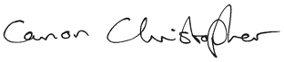

Very Reverend Christopher Canon Matthews

Diocesan RCIA Coordinator

2024 DATES

Saturday 3 February
Reflection with Bishop Mark,
Holy Angels Parish Hall, Hale Barns
10:00am – 12 noon

Sunday 18 February
Rite of Election – Shrewsbury Cathedral
2:45pm for 3pm

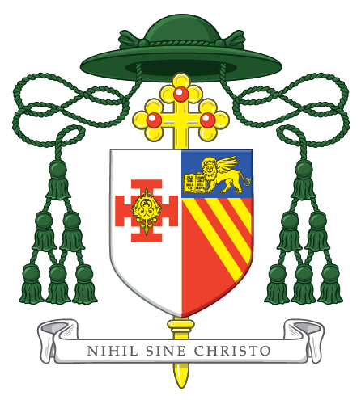
The Right Reverend Mark Davies
Bishop of Shrewsbury

invites you to join him for a time of reflection

on Saturday 3 February 2024
at Holy Angels Parish Hall
(Wicker Lane, Hale Barns, Altrincham WA15 0HF)

All Catechumens, Candidates, Godparents,
Sponsors and Catechists are welcome.

Doors open at 10:00am for coffee and refreshments.
The day includes two reflections with Bishop Mark,
and will conclude after the Angelus prayer at Noon.



Booking is essential, please do so through your RCIA Catechist.

The Right Reverend Mark Davies
Bishop of Shrewsbury

Invites you to the Rite of Election

on Sunday 18 February 2024 at 3pm
at The Cathedral Church of
Our Lady Help of Christians & Saint Peter of Alcantara
(Town Walls, Shrewsbury, SY1 1TE)

Booking is essential; please do so through your RCIA Catechist.

2pm Arrivals
2.30pm Preparation together - please be in your seats by 2.45pm
3.00pm Rite of Election and Celebration of Ongoing Conversion
Followed by refreshments

We look forward to welcoming you to The Cathedral

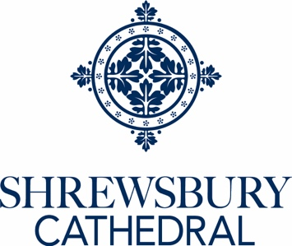

What is the Rite of Election?

Our celebration of the Rite of Election marks a significant stage in your journey of preparation into full communion with the Catholic Church.
The phrase, ‘Rite of Election’, may seem a little unfamiliar. In our context it has nothing to do with politics. Rather it is a declaration by the community of Faith that God has called us to be ‘a chosen race, a royal priesthood, a holy nation, a people set apart.’ Each of us is called to praise the wonderful works of God in our daily lives and this is true whether we are already members of the Church or we are preparing to be.

Furthermore, we receive this call in and through the Community of the Church and it is precisely because of this that the Father of our community presides over our celebration. Our Bishop, The Right Reverend Mark Davies, is the shepherd of the Diocese. Celebrating the Rite together reminds us that, although we are members of our parish communities and form a diocesan family, we are also a part of the Body of Christ, the Universal Church, which embraces people of all nations and is the sign on earth of God’s everlasting love and fidelity. The Rite of Election and Call to ongoing conversion, is celebrated on the First Sunday of Lent in Cathedrals across the Universal Church.

The enrolment of names that takes place during the Rite is not simply a question of ‘signing on’. Rather it is a visible expression of personal commitment. Those who enrol at the Rite of Election wish to commit themselves to the life and mission of the Church, and the acceptance of this commitment by the Bishop is the moment of election.

We look forward to receiving you all as our guests on 18 February.


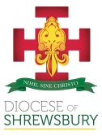
RCIA BOOKING FORM
Please return to the RCIA Coordinator by Friday 26 January 2024
Curial Offices, 2 Park Road South, Prenton, Wirral, CH43 4UX
0151 652 9855 E: anthony.timothy@dioceseofshrewsbury.org www.dioceseofshrewsbury.org

PARISH DETAILS
Parish Name: |  | Parish Town:
RCIA COORDINATOR DETAILS
Name:
Email:
Mobile:

Privacy Notice: The information collected on this form helps with the preparation of RCIA Catechumens and Candidates. Some of the Information that you provide on this form will be added to the Baptism Register and the Book of the Elect (if you are a Catechumen) and will be entered into the Book of Ongoing Conversion (if you are a Candidate). The information will be stored indefinitely in a secure location in accordance with the laws and procedures of the Roman Catholic faith for future sacramental purposes, (for example marriage purposes) and for history. The details that you provide on this form will not be transferred to any third party to use for their own marketing or fundraising purpose. You can read our full Privacy Notice at www.dioceseofshrewsbury.org/about us/privacy-notice.
RCIA BOOKING FORM
Please return to the RCIA Coordinator by Friday 26 January 2024
Curial Offices, 2 Park Road South, Prenton, Wirral, CH43 4UX
0151 652 9855 E: anthony.timothy@dioceseofshrewsbury.org www.dioceseofshrewsbury.org

CATECHUMEN DETAILS
Title | First Name | Surname | Age if under 18 | Retreat Day (please tick) | Rite of Election (Please tick) | Godparents name | Special Requirements (mobility/dietary/etc) | How Many accompanying to Retreat Day | How many accompanying to the Rite of Election
Privacy Notice: The information collected on this form helps with the preparation of RCIA Catechumens and Candidates. Some of the Information that you provide on this form will be added to the Baptism Register and the Book of the Elect (if you are a Catechumen) and will be entered into the Book of Ongoing Conversion (if you are a Candidate). The information will be stored indefinitely in a secure location in accordance with the laws and procedures of the Roman Catholic faith for future sacramental purposes, (for example marriage purposes) and for history. The details that you provide on this form will not be transferred to any third party to use for their own marketing or fundraising purpose. You can read our full Privacy Notice at www.dioceseofshrewsbury.org/about us/privacy-notice.
RCIA BOOKING FORM
Please return to the RCIA Coordinator by Friday 26 January 2024
Curial Offices, 2 Park Road South, Prenton, Wirral, CH43 4UX
0151 652 9855 E: anthony.timothy@dioceseofshrewsbury.org www.dioceseofshrewsbury.org

CANDIDATE DETAILS
Title | First Name | Surname | Age if under 18 | Retreat Day (please tick) | Rite of Election (Please tick) | Sponsor name | Special Requirements (mobility/dietary/etc) | How Many accompanying to Retreat Day | How many accompanying to the Rite of Election

Privacy Notice: The information collected on this form helps with the preparation of RCIA Catechumens and Candidates. Some of the Information that you provide on this form will be added to the Baptism Register and the Book of the Elect (if you are a Catechumen) and will be entered into the Book of Ongoing Conversion (if you are a Candidate). The information will be stored indefinitely in a secure location in accordance with the laws and procedures of the Roman Catholic faith for future sacramental purposes, (for example marriage purposes) and for history. The details that you provide on this form will not be transferred to any third party to use for their own marketing or fundraising purpose. You can read our full Privacy Notice at www.dioceseofshrewsbury.org/about us/privacy-notice.

